Development Release Notes
  - Machine Studio v4.2 | PPC v1.2 | FSE v1.1

Machine Serial Number and Organization Change
This version of the system supports modifying a machine’s serial number and organization without performing factory reset.
This is a major architectural change that require testing.
I request the QA team to perform tests on the following areas:
- The PPC updates flawlessly from the current version to this new version.
There is a complex procedure called “Auth2” that will be executed as a pre-update package when updating to this new version. (make sure you see it executing)
We need to make sure everything runs smoothly on different states of the PPC. (e.g. PPC with/without sites)
- Changing a machine’s serial number or organization does not lead to any discrepancies when updating a machine after the change.
- What happens when you assign a machine to a different organization and that machine was already assigned to a site of the previous organization.

New Versioning Scheme
PPC, FSE and Machine Studio will now be released using a new versioning scheme.
This new scheme makes it easier to keep track on version updates and contribute to versions numbering consistency.
[A].[B].[C].[D]

A: Major.
This number will increment only when there is a major change or breaking changes in the software.

B: Minor
This number will increment on each release.

C: Revision
This number will increment on each QA cycle.

D: Build Date
In the format of YY MM DD, (The release date can be extracted from the version)

From now on, clients and R&D teams that comes after the QA should care only about the A.B part of the version.
This is because after releasing a version for testing, most of the times, in a time span of 2, 3 days, I am fixing bugs, making small improvements and releasing again for testing.
The C part (revision) will allow me to increase the version without affecting the "known" version (A.B) and confusing the rest of the teams about the version number they are expecting.
Also, the C part can tell us how many QA cycles an A.B version had passed before it reached alpha.

Persistent Events
Persistent events are a new kind of events. Like standard events, they appear at the top of the PPC screen.
Unlike a standard event, a persistent event has no activity time, it does not remain on the screen until something is “resolved”.
A persistent event represents something that happened in the past. For example, an “ink filling was completed successfully” or “waste emptying failed”.
Some events or actions in the system do not have a lifespan, they just happened...
You can see persistent events as “notifications” notifying about something that happened in the past.
Unlike standard events, persistent events notifications can be closed by the user.
Persistent events will not be visible in the “Active” events area of the PPC. They will be inserted directly into the “Event History”.
This is because they do not represent something that is “Active” only something that happened.

Persistent events opens many possibilities for the firmware device to communicate with the user by means of “notifications”.
This will drastically reduce development efforts on the PPC system.

Gradients Generation via Color Conversion Engine
The latest color conversion engine v4 now supports generating gradients in RGB color space.
This feature aims to provide more accurate and faster gradients.
Enabling this feature must be specified on each specific thread using Machine Studio.
First the only engine version that supports generating gradients is 4, so “Color Conversion Version” must be set to 4.
Also, check “Enable Gradient Generation”. This will direct system to generate the gradients using the color conversion engine instead of the legacy mode, when dyeing a job.
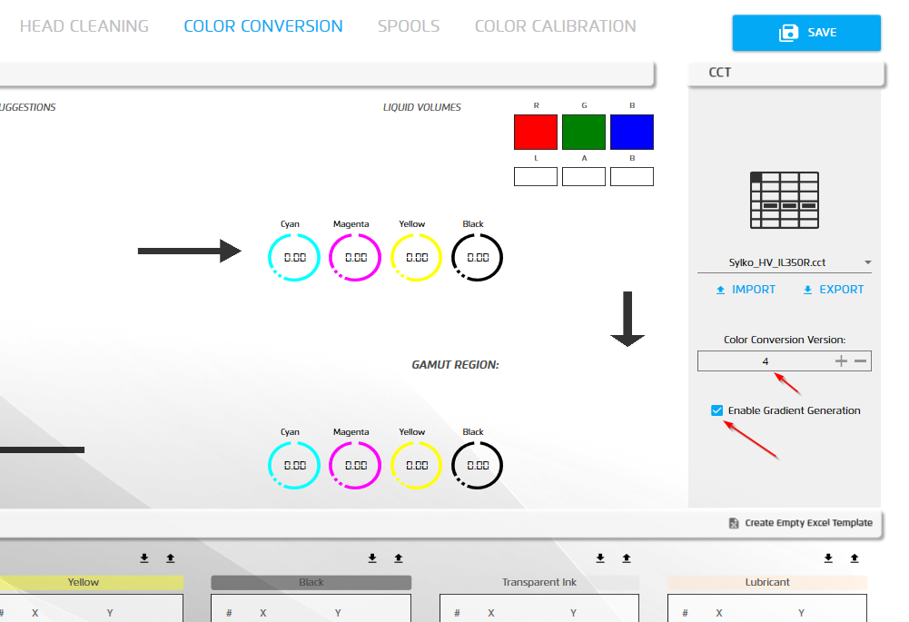

Other Changes

Added new "Arc Head Cleaning Motor Speed" to “Head Cleaning” section on RML.
- Updated event types definitions to revision 27.

PPC v1.2

Notification bar Refactored
The PPC notification bar was refactored to be simpler and more robust, thus eliminating all kinds of esoteric bugs.
- The new implementation will include the entire message detail without scrolling down.
- Minimum animations.

LAN (cable) connectivity indicator.
LAN connectivity indication requested by VVC was implemented. (require testing)
The PPC will now display a LAN connection status icon near the current WiFi icon.
Once the cable is connected, it should turn green.

Update prevention while dyeing.
The PPC will now prevent the user from navigating to the update screen while a job is dyeing.
Standby button support (Main Menu).
Dropped support for “Additional Tools” (Fine Tuning/Sample Dyeing) on the job editing screen.
As requested by the application team.
Job execution prevention when liquid volumes are out of range.
Added support for ink/waste filling/emptying progress.
PPC now supports the full tracking of ink filling progress.
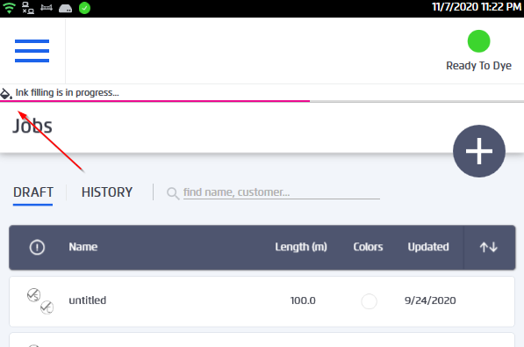
The progress of the color bar will be determined by the color of the cartridge.
Also supported, tracking of waste emptying progress.
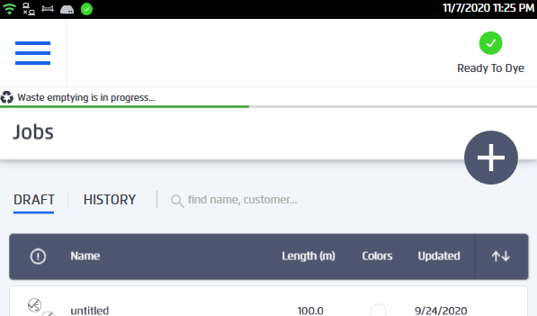
Ink and Waste filling/emptying can be displayed in parallel.
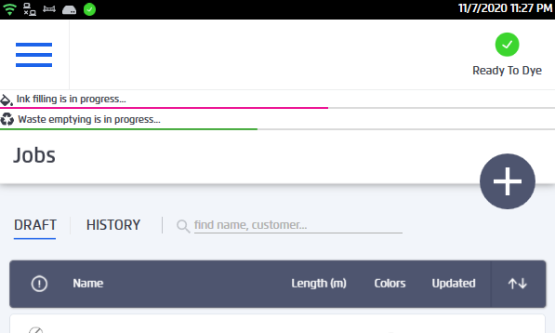

Added support for waste status on maintenance screen
PPC now supports the full tracking of ink filling progress.
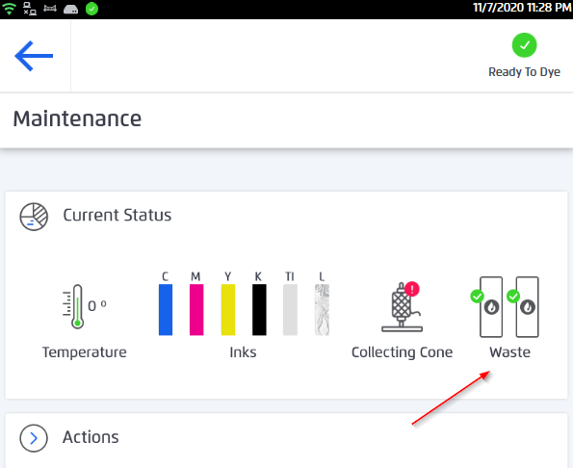

FSE v1.1

General (Minor) Improvements Bug Fixes
Procedures Improvements
- Drastically improved loading time of procedure designer.
- Improved support for extension methods.

Machine Studio v4.2

General (Minor) Improvements Bug Fixes
Implemented auto reconnection for USB connection (Mati)

